UNIVERSITY OF WAH (UOW)

DEPARTMENT OF COMPUTER SCIENCE



COURSE TITLE: INTRO TO INFORMATION SECURITY

COURSE CODE: CS – 251 L

SUBMITTED TO: MS. WASIFA KANWAL

SUBMITTED BY: SAADI SAFDAR

REG #: UW-24-CS-BS-088

BSCS 3RD B

LAB ASSIGNMENT # 8

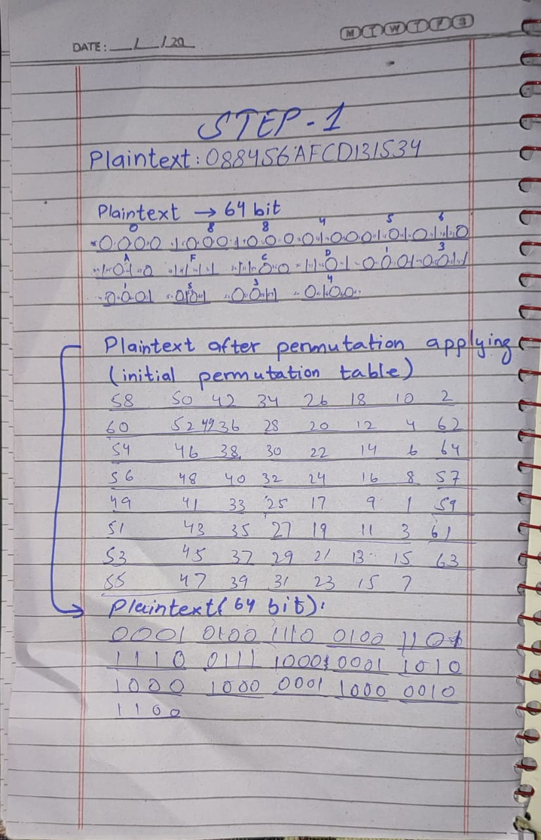

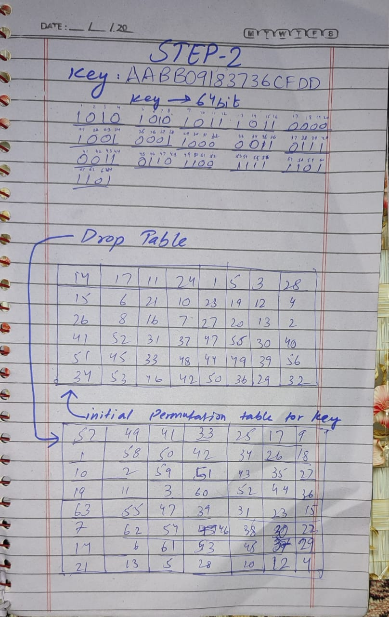

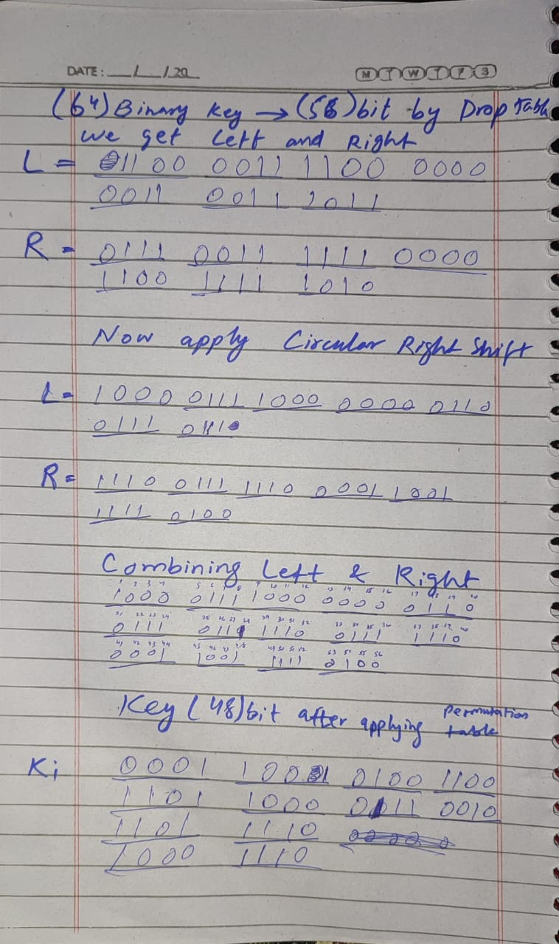

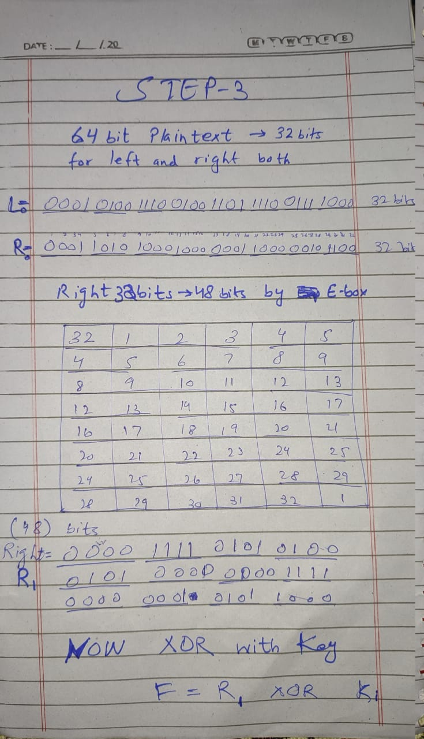

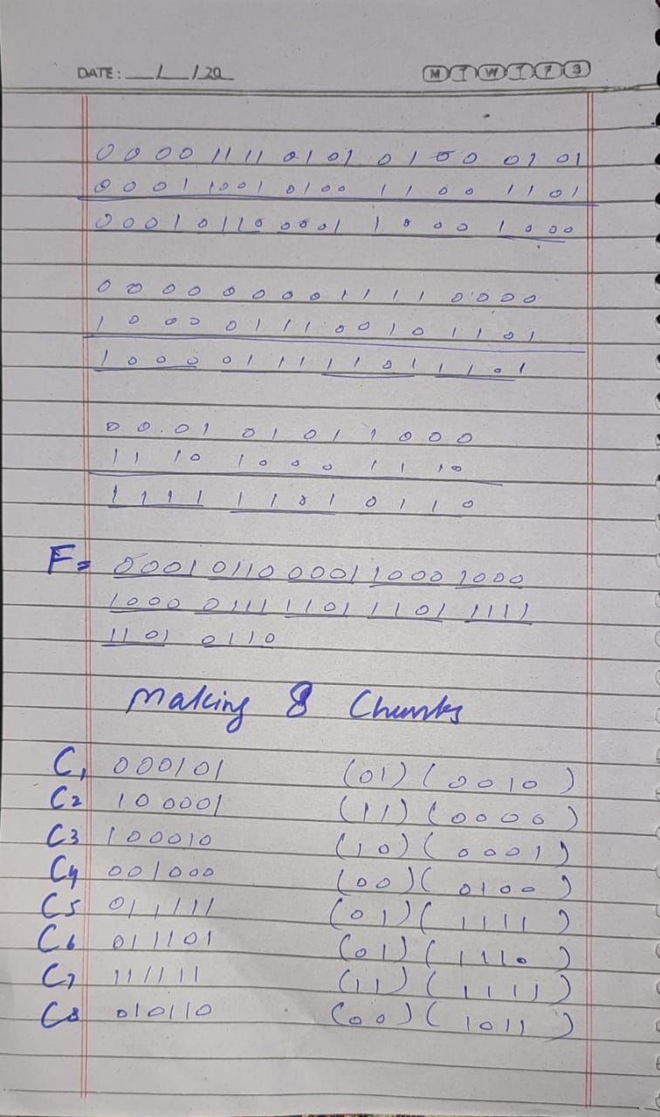

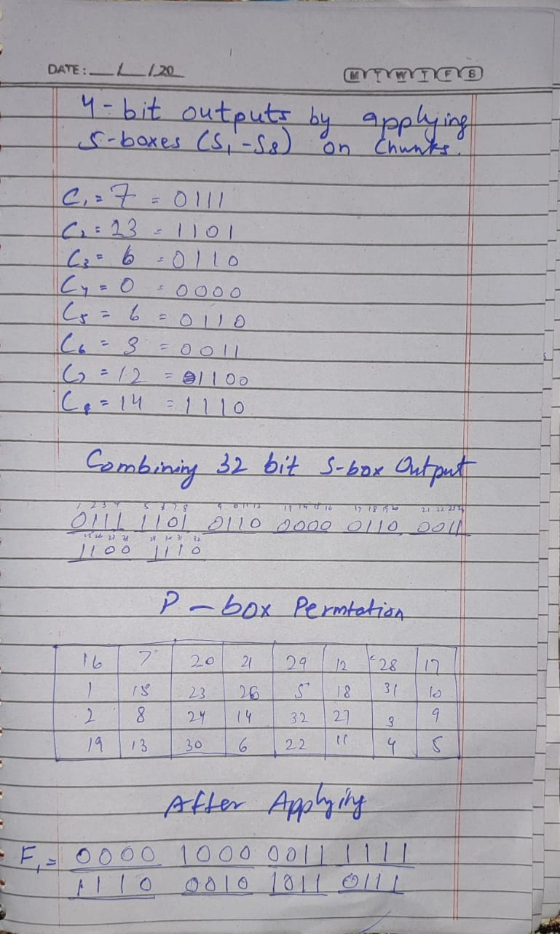

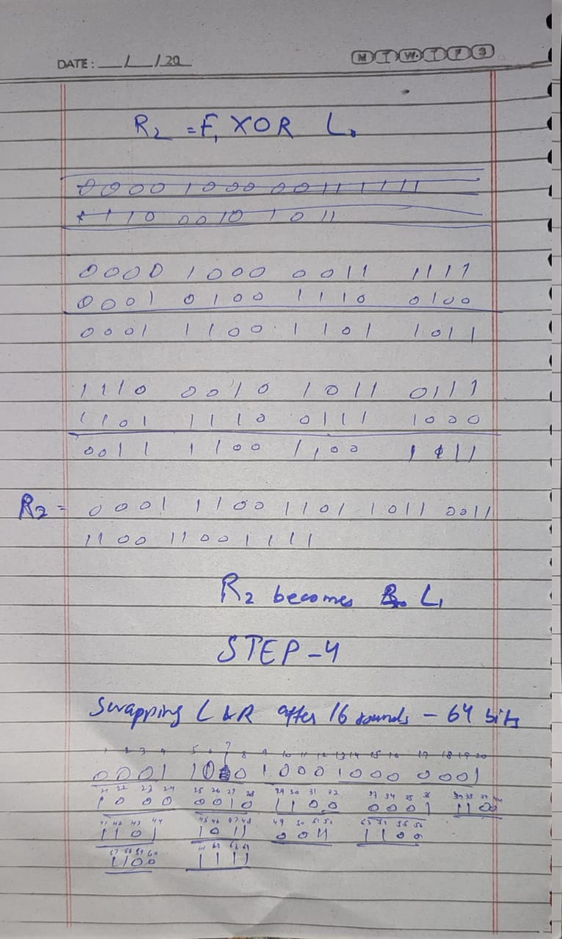

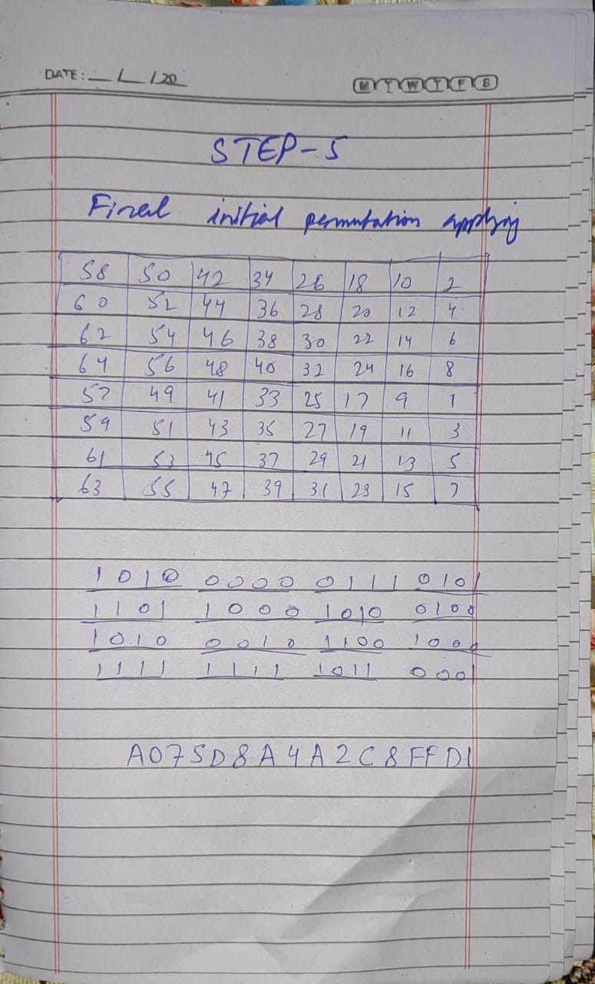

def hex2bin(s):
mp = {'0': "0000",
'1': "0001",
'2': "0010",
'3': "0011",
'4': "0100",
'5': "0101",
'6': "0110",
'7': "0111",
'8': "1000",
'9': "1001",
'A': "1010",
'B': "1011",
'C': "1100",
'D': "1101",
'E': "1110",
'F': "1111"}
bin_str = ""
for i in range(len(s)):
bin_str = bin_str + mp[s[i]]
return bin_str

# Binary to hexadecimal conversion
def bin2hex(s):
mp = {"0000": '0',
"0001": '1',
"0010": '2',
"0011": '3',
"0100": '4',
"0101": '5',
"0110": '6',
"0111": '7',
"1000": '8',
"1001": '9',
"1010": 'A',
"1011": 'B',
"1100": 'C',
"1101": 'D',
"1110": 'E',
"1111": 'F'}
hex_str = ""
for i in range(0, len(s), 4):
ch = s[i:i+4]
hex_str = hex_str + mp[ch]
return hex_str

# Binary to decimal conversion
def bin2dec(binary):
return int(binary, 2)

# Decimal to binary conversion
def dec2bin(num):
res = bin(num).replace("0b", "")
if(len(res) % 4 != 0):
div = len(res) / 4
div = int(div)
counter = (4 * (div + 1)) - len(res)
for i in range(0, counter):
res = '0' + res
return res

# Permute function to rearrange the bits
def permute(k, arr, n):
permutation = ""
for i in range(0, n):
permutation = permutation + k[arr[i] - 1]
return permutation

# shifting the bits towards left by nth shifts
def shift_left(k, nth_shifts):
s = ""
for i in range(nth_shifts):
for j in range(1, len(k)):
s = s + k[j]
s = s + k[0]
k = s
s = ""
return k

# calculating xor of two strings of binary number a and b
def xor(a, b):
ans = ""
for i in range(len(a)):
if a[i] == b[i]:
ans = ans + "0"
else:
ans = ans + "1"
return ans

# Table of Position of 64 bits at initial level: Initial Permutation Table
initial_perm = [58, 50, 42, 34, 26, 18, 10, 2,
60, 52, 44, 36, 28, 20, 12, 4,
62, 54, 46, 38, 30, 22, 14, 6,
64, 56, 48, 40, 32, 24, 16, 8,
57, 49, 41, 33, 25, 17, 9, 1,
59, 51, 43, 35, 27, 19, 11, 3,
61, 53, 45, 37, 29, 21, 13, 5,
63, 55, 47, 39, 31, 23, 15, 7]

# Expansion D-box Table
exp_d = [32, 1, 2, 3, 4, 5, 4, 5,
6, 7, 8, 9, 8, 9, 10, 11,
12, 13, 12, 13, 14, 15, 16, 17,
16, 17, 18, 19, 20, 21, 20, 21,
22, 23, 24, 25, 24, 25, 26, 27,
28, 29, 28, 29, 30, 31, 32, 1]

# Straight Permutation Table
per = [16, 7, 20, 21,
29, 12, 28, 17,
1, 15, 23, 26,
5, 18, 31, 10,
2, 8, 24, 14,
32, 27, 3, 9,
19, 13, 30, 6,
22, 11, 4, 25]

# S-box Table
sbox = [[[14, 4, 13, 1, 2, 15, 11, 8, 3, 10, 6, 12, 5, 9, 0, 7],
[0, 15, 7, 4, 14, 2, 13, 1, 10, 6, 12, 11, 9, 5, 3, 8],
[4, 1, 14, 8, 13, 6, 2, 11, 15, 12, 9, 7, 3, 10, 5, 0],
[15, 12, 8, 2, 4, 9, 1, 7, 5, 11, 3, 14, 10, 0, 6, 13]],

[[15, 1, 8, 14, 6, 11, 3, 4, 9, 7, 2, 13, 12, 0, 5, 10],
[3, 13, 4, 7, 15, 2, 8, 14, 12, 0, 1, 10, 6, 9, 11, 5],
[0, 14, 7, 11, 10, 4, 13, 1, 5, 8, 12, 6, 9, 3, 2, 15],
[13, 8, 10, 1, 3, 15, 4, 2, 11, 6, 7, 12, 0, 5, 14, 9]],

[[10, 0, 9, 14, 6, 3, 15, 5, 1, 13, 12, 7, 11, 4, 2, 8],
[13, 7, 0, 9, 3, 4, 6, 10, 2, 8, 5, 14, 12, 11, 15, 1],
[13, 6, 4, 9, 8, 15, 3, 0, 11, 1, 2, 12, 5, 10, 14, 7],
[1, 10, 13, 0, 6, 9, 8, 7, 4, 15, 14, 3, 11, 5, 2, 12]],

[[7, 13, 14, 3, 0, 6, 9, 10, 1, 2, 8, 5, 11, 12, 4, 15],
[13, 8, 11, 5, 6, 15, 0, 3, 4, 7, 2, 12, 1, 10, 14, 9],
[10, 6, 9, 0, 12, 11, 7, 13, 15, 1, 3, 14, 5, 2, 8, 4],
[3, 15, 0, 6, 10, 1, 13, 8, 9, 4, 5, 11, 12, 7, 2, 14]],

[[2, 12, 4, 1, 7, 10, 11, 6, 8, 5, 3, 15, 13, 0, 14, 9],
[14, 11, 2, 12, 4, 7, 13, 1, 5, 0, 15, 10, 3, 9, 8, 6],
[4, 2, 1, 11, 10, 13, 7, 8, 15, 9, 12, 5, 6, 3, 0, 14],
[11, 8, 12, 7, 1, 14, 2, 13, 6, 15, 0, 9, 10, 4, 5, 3]],

[[12, 1, 10, 15, 9, 2, 6, 8, 0, 13, 3, 4, 14, 7, 5, 11],
[10, 15, 4, 2, 7, 12, 9, 5, 6, 1, 13, 14, 0, 11, 3, 8],
[9, 14, 15, 5, 2, 8, 12, 3, 7, 0, 4, 10, 1, 13, 11, 6],
[4, 3, 2, 12, 9, 5, 15, 10, 11, 14, 1, 7, 6, 0, 8, 13]],

[[4, 11, 2, 14, 15, 0, 8, 13, 3, 12, 9, 7, 5, 10, 6, 1],
[13, 0, 11, 7, 4, 9, 1, 10, 14, 3, 5, 12, 2, 15, 8, 6],
[1, 4, 11, 13, 12, 3, 7, 14, 10, 15, 6, 8, 0, 5, 9, 2],
[6, 11, 13, 8, 1, 4, 10, 7, 9, 5, 0, 15, 14, 2, 3, 12]],

[[13, 2, 8, 4, 6, 15, 11, 1, 10, 9, 3, 14, 5, 0, 12, 7],
[1, 15, 13, 8, 10, 3, 7, 4, 12, 5, 6, 11, 0, 14, 9, 2],
[7, 11, 4, 1, 9, 12, 14, 2, 0, 6, 10, 13, 15, 3, 5, 8],
[2, 1, 14, 7, 4, 10, 8, 13, 15, 12, 9, 0, 3, 5, 6, 11]]]

# Final Permutation Table
final_perm = [58, 50, 42, 34, 26, 18, 10, 2,
60, 52, 44, 36, 28, 20, 12, 4,
62, 54, 46, 38, 30, 22, 14, 6,
64, 56, 48, 40, 32, 24, 16, 8,
57, 49, 41, 33, 25, 17, 9, 1,
59, 51, 43, 35, 27, 19, 11, 3,
61, 53, 45, 37, 29, 21, 13, 5,
63, 55, 47, 39, 31, 23, 15, 7]

def encrypt(pt, rkb, rk):
pt = hex2bin(pt)
# Initial Permutation
pt = permute(pt, initial_perm, 64)
print("After initial permutation", bin2hex(pt))
# Splitting
left = pt[0:32]
right = pt[32:64]
# Note: The PDF shows only 1 round, but DES should have 16 rounds
# Based on the PDF, we'll do only 1 round as shown in the example
for i in range(0, 1):
# Expansion D-box: Expanding the 32 bits data into 48 bits
right_expanded = permute(right, exp_d, 48)
print("rightexpanded", bin2hex(right_expanded))
# XOR RoundKey[i] and right_expanded
xor_x = xor(right_expanded, rkb[i])
print("xor", bin2hex(xor_x))
# S-boxes: substituting the value from s-box table by calculating row and column
sbox_str = ""
for j in range(0, 8):
row = bin2dec(xor_x[j * 6] + xor_x[j * 6 + 5])
col = bin2dec(xor_x[j * 6 + 1] + xor_x[j * 6 + 2] + xor_x[j * 6 + 3] + xor_x[j * 6 + 4])
val = sbox[j][row][col]
sbox_str = sbox_str + dec2bin(val)
# Straight D-box: After substituting rearranging the bits
print("sbox_str", bin2hex(sbox_str))
sbox_str = permute(sbox_str, per, 32)
print("sbox_str after permutation", bin2hex(sbox_str))
# XOR left and sbox_str
result = xor(left, sbox_str)
print("result", bin2hex(result))
left = result
# Swapper (for DES, swap happens except in last round)
# Since we're only doing 1 round, we don't swap
if(i != 15):
left, right = right, left
print("left", bin2hex(left), "right", bin2hex(right))
print("Round ", i + 1, " ", bin2hex(left), " ", bin2hex(right), " ", rk[i])
# Combination
combine = left + right
print("combine", bin2hex(combine))
# Final permutation: final rearranging of bits to get cipher text
cipher_text = permute(combine, final_perm, 64)
print("cipher_text", bin2hex(cipher_text))
return cipher_text

# Main execution
pt = "088456AFCD131534"
key = "AABB09183736CFDD"

print("Plain Text: ", pt)
print("Key: ", key)
print("\n" + "="*50)

# Key generation
# --hex to binary
key = hex2bin(key)
print("Key in binary: ", key)

# --parity bit drop table
keyp = [57, 49, 41, 33, 25, 17, 9,
1, 58, 50, 42, 34, 26, 18,
10, 2, 59, 51, 43, 35, 27,
19, 11, 3, 60, 52, 44, 36,
63, 55, 47, 39, 31, 23, 15,
7, 62, 54, 46, 38, 30, 22,
14, 6, 61, 53, 45, 37, 29,
21, 13, 5, 28, 20, 12, 4]

# getting 56 bit key from 64 bit using the parity bits
key = permute(key, keyp, 56)
print("Key after permutation: ", key)

# Number of bit shifts
shift_table = [1, 1, 2, 2,
2, 2, 2, 2,
1, 2, 2, 2,
2, 2, 2, 1]

# Key- Compression Table : Compression of key from 56 bits to 48 bits
key_comp = [14, 17, 11, 24, 1, 5,
3, 28, 15, 6, 21, 10,
23, 19, 12, 4, 26, 8,
16, 7, 27, 20, 13, 2,
41, 52, 31, 37, 47, 55,
30, 40, 51, 45, 33, 48,
44, 49, 39, 56, 34, 53,
46, 42, 50, 36, 29, 32]

# Splitting
left = key[0:28] # rkb for RoundKeys in binary
right = key[28:56] # rk for RoundKeys in hexadecimal
print("left", left)
print("right", right)

rkb = []
rk = []

# Based on PDF, we're only generating 1 round key
for i in range(0, 1):
# Shifting the bits by nth shifts by checking from shift table
left = shift_left(left, shift_table[i])
right = shift_left(right, shift_table[i])
# Combination of left and right string
combine_str = left + right
print("combine_str", combine_str)
# Compression of key from 56 to 48 bits
round_key = permute(combine_str, key_comp, 48)
rkb.append(round_key)
rk.append(bin2hex(round_key))

print("rkb", rkb)
print("rk", rk)

print("\n" + "="*50)
print("Encryption")
cipher_text = bin2hex(encrypt(pt, rkb, rk))
print("Cipher Text: ", cipher_text)

print("\n" + "="*50)
print("Decryption")
rkb_rev = rkb[::-1]
rk_rev = rk[::-1]
print("Reversed round keys for decryption:", rk_rev)
text = bin2hex(encrypt(cipher_text, rkb_rev, rk_rev))
print("Plain Text: ", text)

